Traffic Sign Classification using Convolutional Neural Networks (CNN)
Task 0 Report
Name: Raghavam Gupta
Branch: Mechanical
Roll NO.: 25135119
Dataset: German Traffic Sign Recognition Benchmark (GTSRB)

1. Introduction
Traffic Sign Recognition is an important computer vision task used in autonomous driving systems and advanced driver assistance systems (ADAS). The objective of this project was to develop a Convolutional Neural Network (CNN) capable of accurately classifying traffic signs from the German Traffic Sign Recognition Benchmark (GTSRB) dataset.
The model was implemented using PyTorch and trained on traffic sign images belonging to 43 different classes.

2. Dataset Description
The GTSRB dataset contains images of German traffic signs captured under different environmental conditions.
Dataset Statistics
- Number of Classes: 43
- Total Training Images: 39,209
- Validation Images: 7,842
- Image Size after Preprocessing: 32 × 32 pixels
The dataset was loaded using TorchVision's ImageFolder utility.

3. Data Preprocessing
The following preprocessing steps were applied:
- Images were resized to 32 × 32 pixels.
- Images were converted into PyTorch tensors.
- The dataset was split into:
  - 80% Training Data
  - 20% Validation Data
- DataLoaders were created with a batch size of 64.
These steps ensured consistency in image dimensions and efficient batch processing during training.

4. CNN Architecture
A custom Convolutional Neural Network was designed consisting of:
Feature Extraction Layers
- Conv2D (3 → 32)
- Batch Normalization
- ReLU Activation
- Max Pooling
- Conv2D (32 → 64)
- Batch Normalization
- ReLU Activation
- Max Pooling
- Conv2D (64 → 128)
- Batch Normalization
- ReLU Activation
- Max Pooling
Classification Layers
- Flatten Layer
- Fully Connected Layer (2048 → 256)
- ReLU Activation
- Dropout (0.3)
- Output Layer (256 → 43)
This architecture extracts hierarchical image features and performs multi-class classification across 43 traffic sign categories.

5. Training Configuration
The model was trained using the following configuration:
Parameter | Value
Optimizer | Adam
Loss Function | CrossEntropyLoss
Batch Size | 64
Epochs | 5
Framework | PyTorch
Training and validation loss were recorded after every epoch.

6. Results
Training and Validation Loss
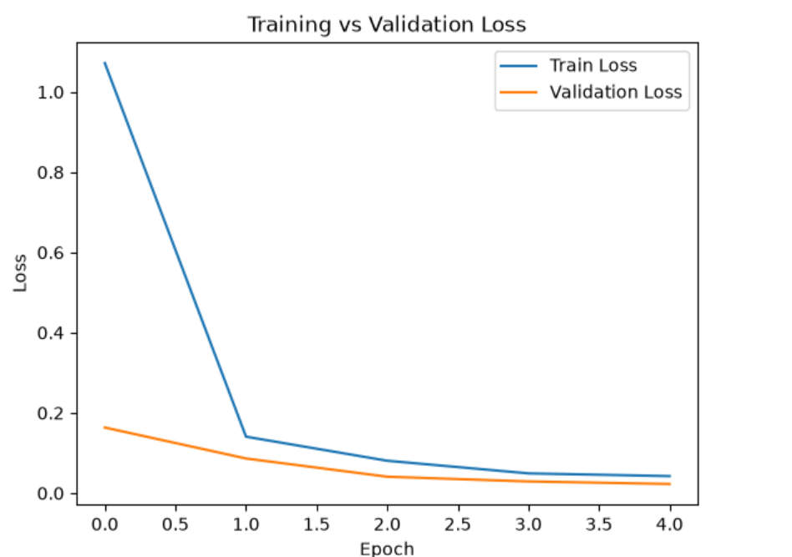

Confusion Matrix
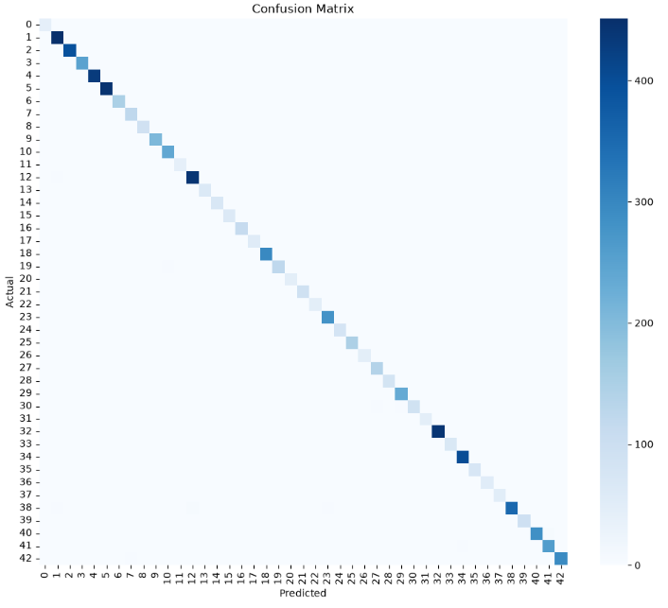

Sample Predictions
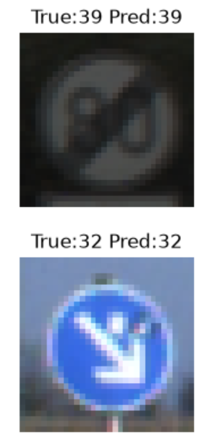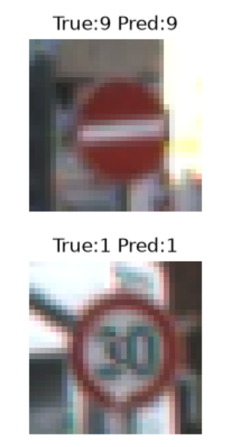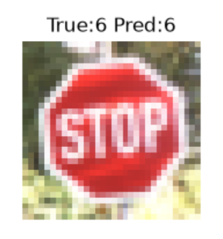
Final Performance
Validation Accuracy: 99.35%
The model achieved excellent classification performance with very low validation loss and high prediction accuracy across all classes.

7. Discussion
The CNN successfully learned discriminative traffic sign features. Batch Normalization improved training stability, while Dropout helped reduce overfitting.
The confusion matrix shows that most predictions lie along the diagonal, indicating strong classification performance across nearly all traffic sign categories.
Possible future improvements include:
- Data Augmentation
- Learning Rate Scheduling
- Transfer Learning
- Deeper CNN Architectures

8. Conclusion
A Convolutional Neural Network was successfully implemented for traffic sign classification using the GTSRB dataset.
The model achieved a validation accuracy of 99.35%, demonstrating excellent performance on the validation dataset. The project provided practical experience in image preprocessing, CNN design, model training, and evaluation using PyTorch.

9. AI Assistance
During the completion of this project, AI-assisted tools were used for conceptual guidance, debugging support, environment setup assistance, and report drafting. These tools were utilized as learning aids throughout the development process.

